Sprint 4 Report

Scrum Tools, by the Scrum Mates, 3/9/2024

# Actions to stop doing

Our team should stop letting tasks overflow from one sprint and continue into the next one because the tasks should be contained within a sprint, and anything carried over stops us from working on the new features.

# Actions to start doing

Our team should start turning on their cameras and microphones more often during meetings whenever it is possible so that we stay more engaged with the meetings. Our team should also start seeking more work when we are done with our tasks, whether that is helping on other tasks or adding more stories to the sprint, because there was not enough pressure for some team members.

# Actions to keep doing

# The team should keep holding work and design meetings because it helps us get started on work and design, and keeps us a little more organized and in sync. The team should also keep showing demos of their work when it has been somewhat developed so that everyone can give feedback for it.

# Work Completed/Not completed

Completed tasks and stories are crossed out

### Story 1

| **Priority** | **Story** | **Acceptance Criteria** | **SP** |
| --- | --- | --- | --- |
| 1 - Must | As a product owner, I want to add a new sprint to an editable release plan so that I can plan the sprints while making the release plan. | Can add a new sprint to the release plan.  Looks better  Can remove sprints  Can edit sprints | 3 |

### 

| **Tasks** | **Ideal Hours** |
| --- | --- |
| 1. ~~Add features to delete sprints.~~ | ~~2~~ |
| 1. Add features to add sprints. | 2 |
| 1. ~~Reorder sprints~~ | ~~5~~ |
| 1. ~~Backend function to reorder sprints~~ | ~~1~~ |
| 1. ~~Backend function to delete sprints~~ | ~~2~~ |

### Work Completion Rate

Average user stories/day and average ideal work hours/day figures computed across all sprints to date.

Total number of user of stories completed during the prior sprint: 0

Total number of estimated ideal work hours completed during the prior sprint: 10

Total number of days during the prior sprint: 7 days

User Stories/day = 0/7 = 0 stories/day

Average user stories/day = avg(0, 0, 0.143, 0) = 0.0.358 stories/day

Ideal hours/day = 10/7 = 1.43 ideal hours/day

average ideal hours/day = avg(.86, 1.57, 2.14, 1.43) = 1.50 ideal hours/day

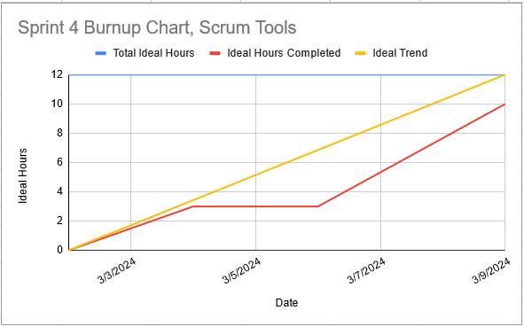

Some team members were busy in the middle of the sprint and couldn’t start working until the end.

# Completed Scrum Board

